**Create K8s Mainfest**

1. **Create pod, replica set and deployment in the same file(deployment.yaml)**

**(Note:**

**Kubectl apply -f (filename) to create 🡺 manifest files)**

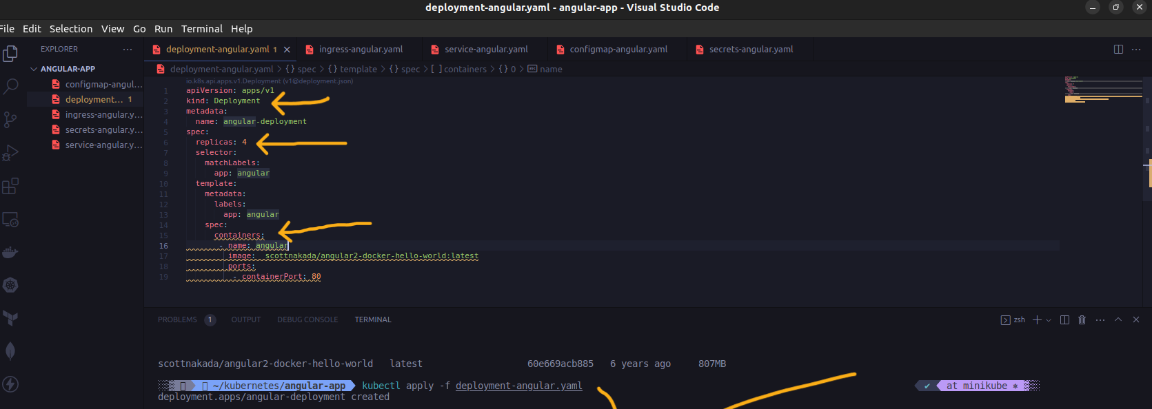

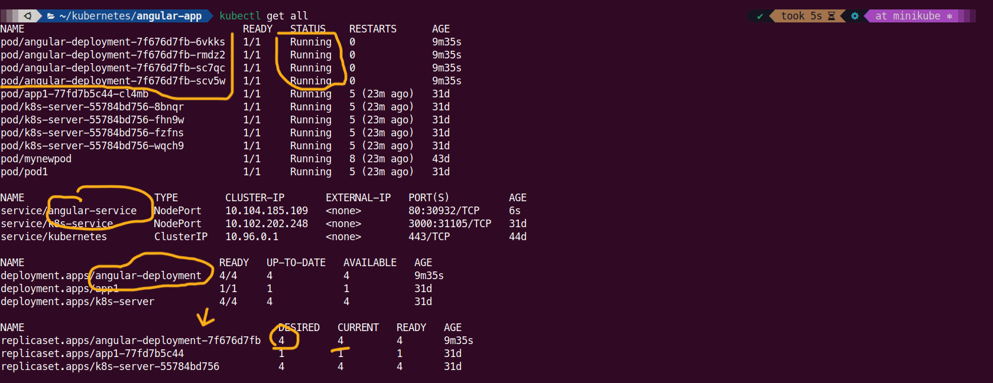

1. **Create Service file.**



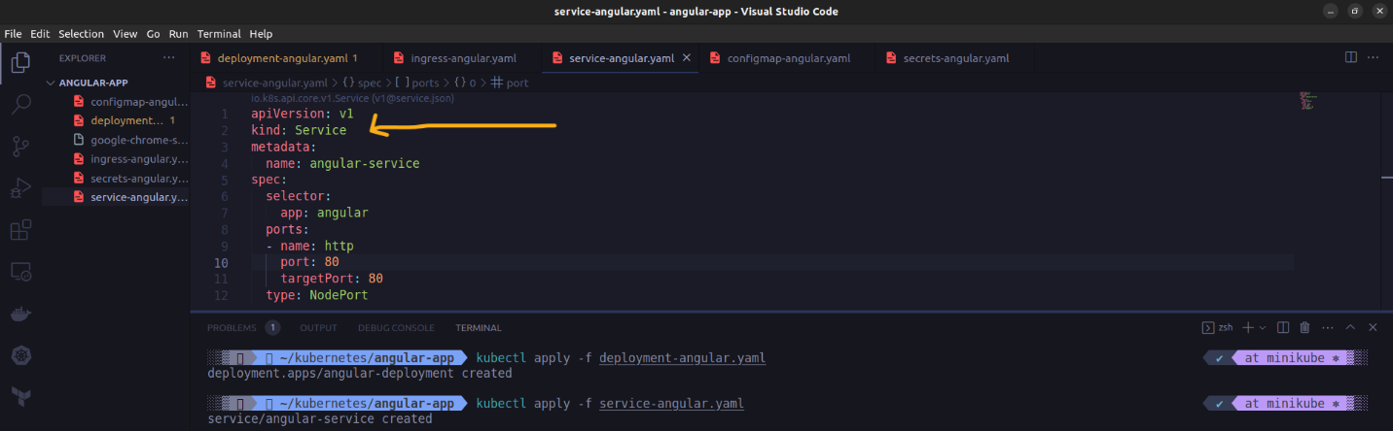

1. **Create ingress file.**

* **Plus add you Ip in hosts file to run Ip external cluster.**

1. **Create Configmap file.**

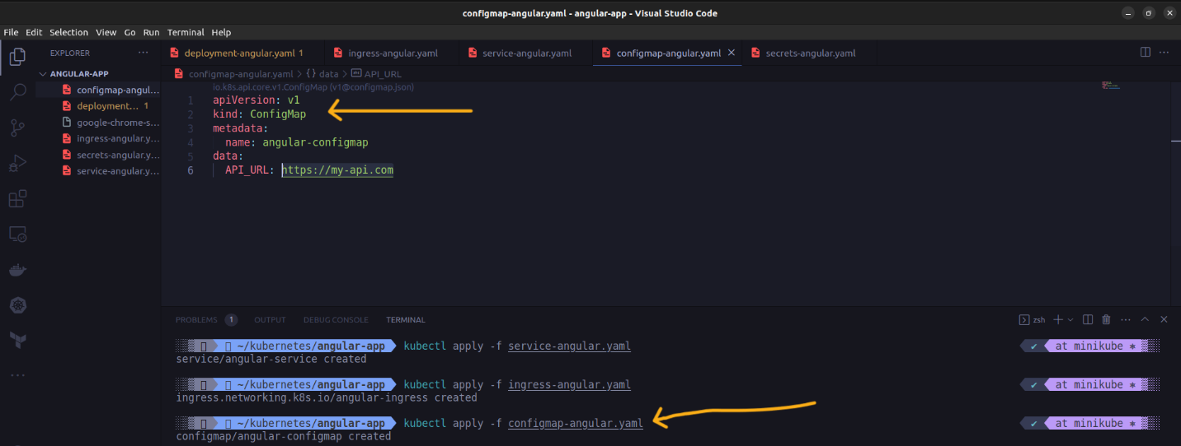

**5- Create Secrets file.**

1. **Final run cluster and show result.**

